Create Storage Account and work with Blob Service – Azure Portal

Step 1: Open Microsoft Azure Portal
https://portal.azure.com

Step 2: Create Storage account
+ Create a resource -> Get Started -> Storage account
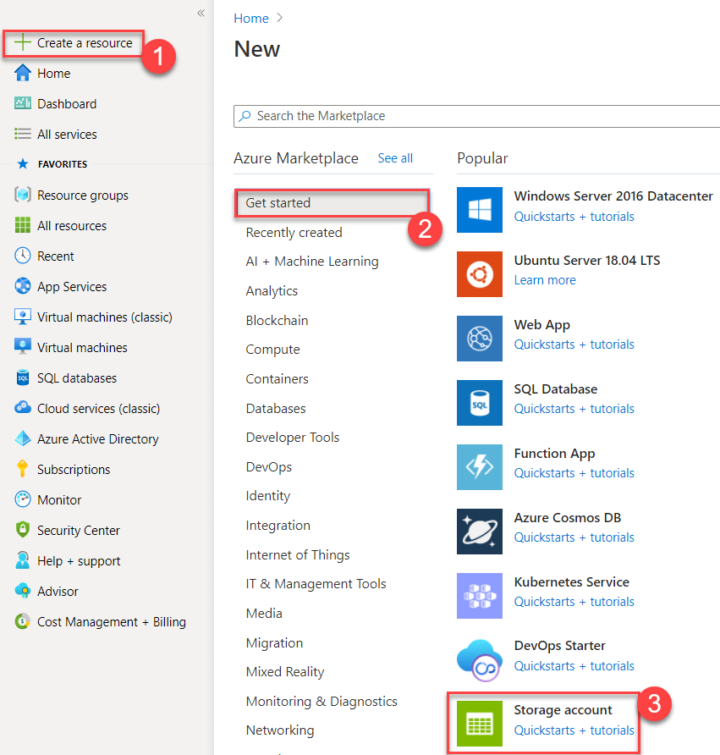

Step 3: Basics tab
Subscription: Choose any active subscription
Resource Group: Create New Resource Group Ex. storagedemoRG
Storage account name: Enter unique name with lowercase Ex. storagedemo20
Region: Choose any nearest location
Performance: Standard
Redundancy: Locally-Redundant Storage (LRS)
Click on Next: Advanced > button

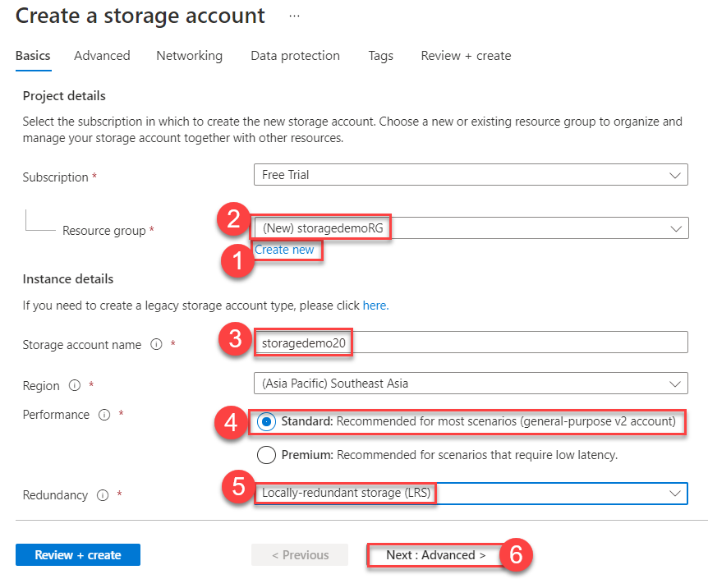

Step 4: Advanced tab
If you wish you can change connectivity method as per your requirement but for this demo you can skip or go with default option.
Click on Next: Networking > button

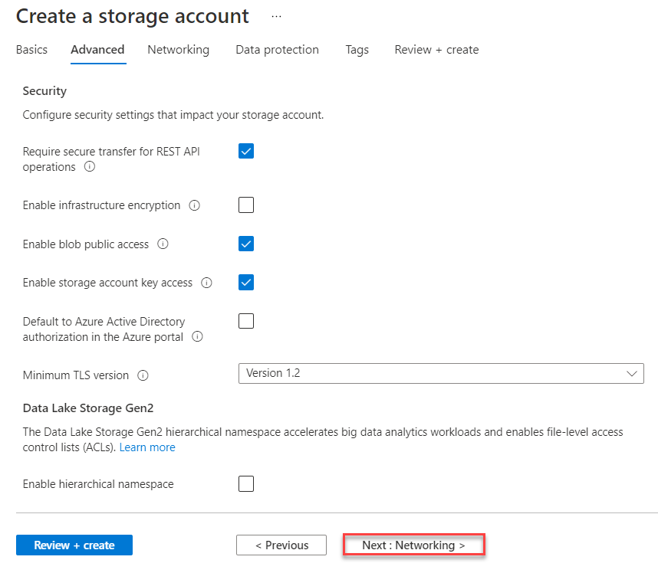

Step 5: Networking tab
If you wish to enable Blob soft delete and file share soft delete option available.
Click on Next: Data protection > button

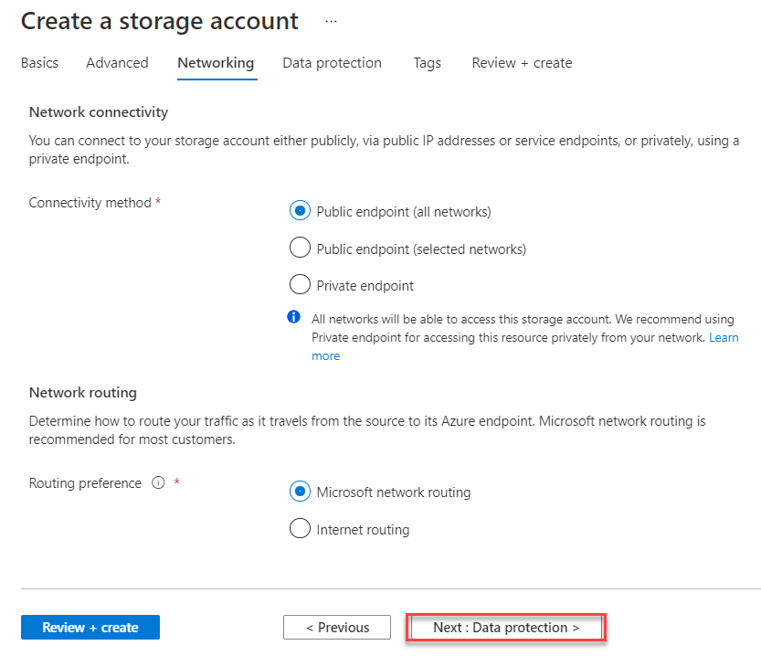
Step 6: Data protection tab
Go with default option
Click on Next: Tags > button.
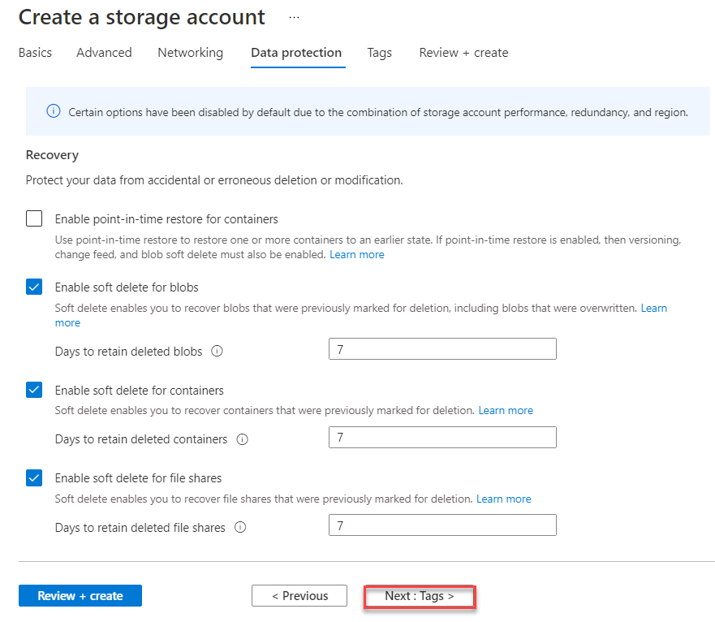

Step 7: Tags tab
Click on Next: Review + Create button
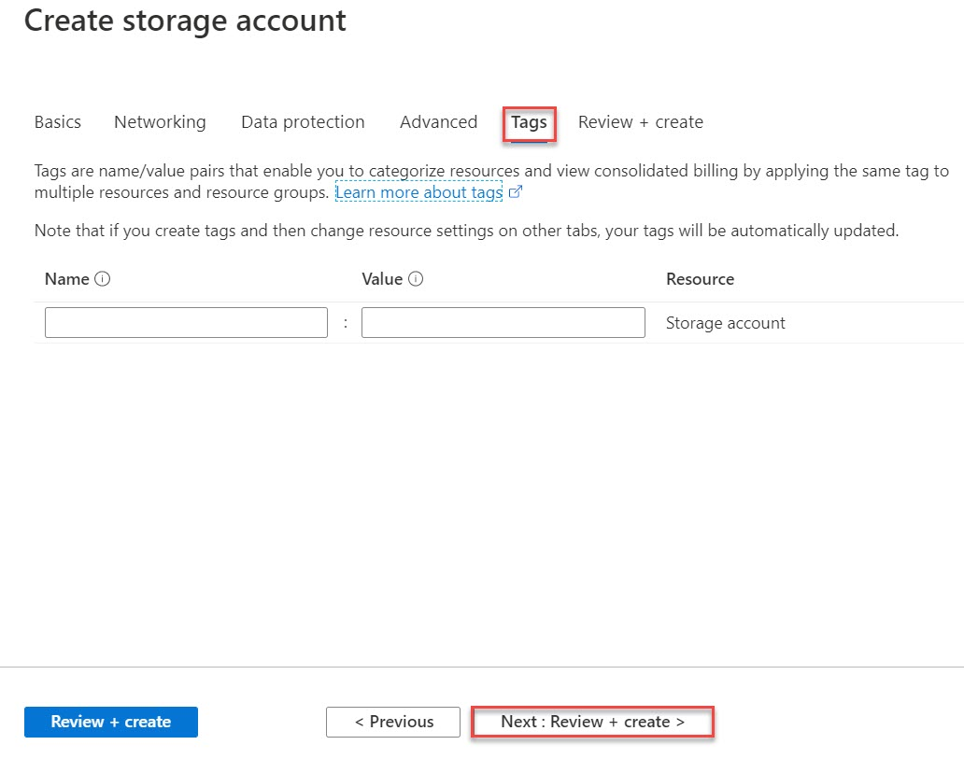

Step 8: Review + Create tab
Wait for validation passed and click on Create button.
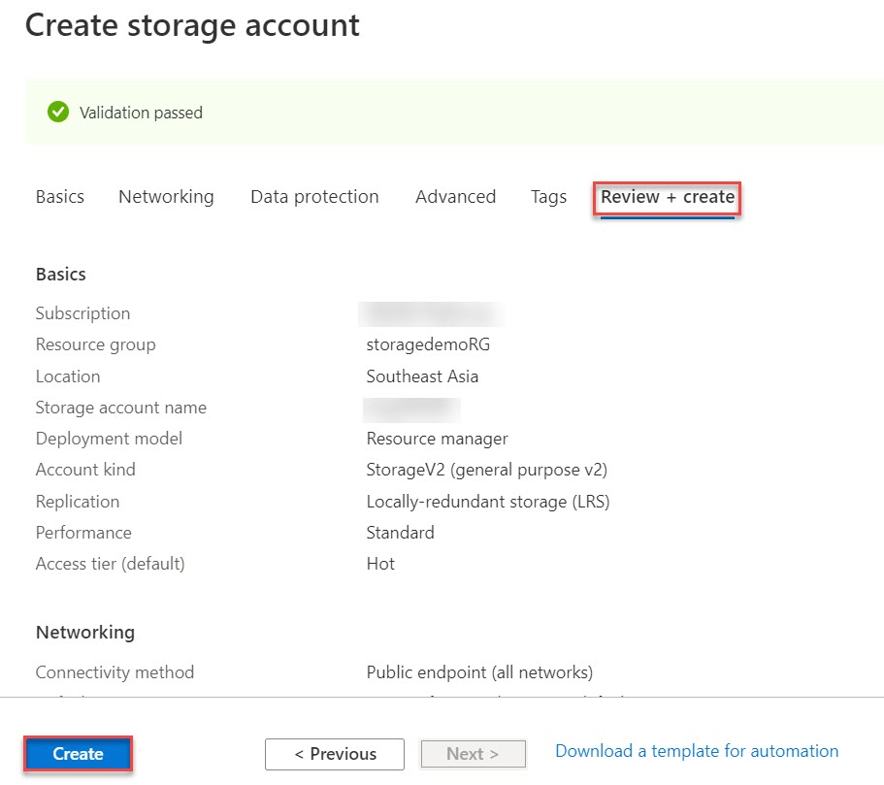
Step 9: Wait for few seconds to create storage account.
Click on Go to resource button.
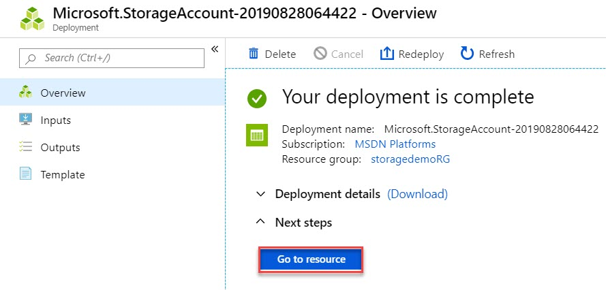

Step 10: Scroll down and navigate to Data storage section. Click on Containers
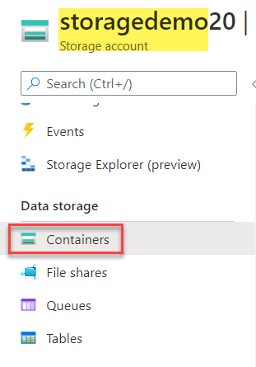

Step 11: Create New Container
Click on + Container option
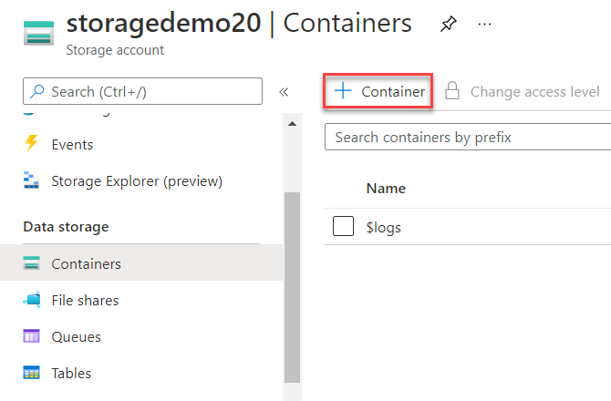

Step 12: Create container with Public access level
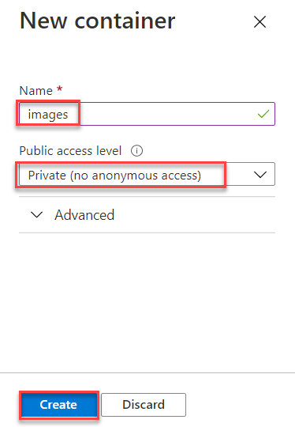
Name: images
Public access level: Private (no anonymous access)
Click on Create button
Step 13: Click on Images container
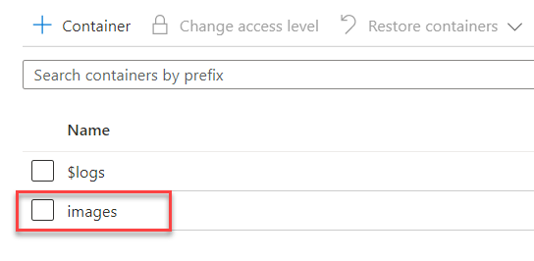

Step 14: Click on Upload button to upload Blob into storage account
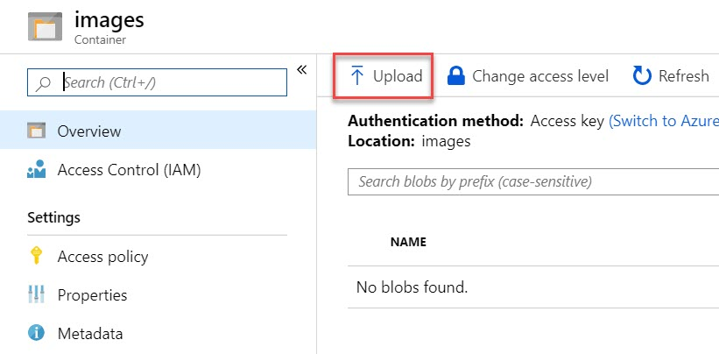

Step 15: Click on Browse option
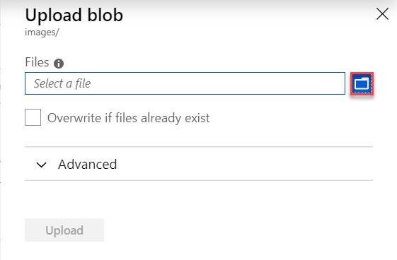

Step 16: Browse any image from local system or from internet.
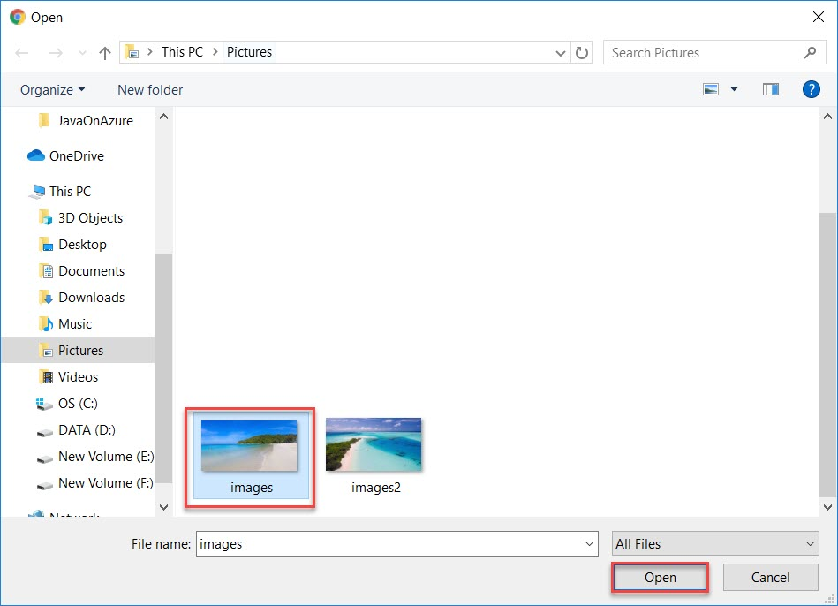
Step 17: Click on Upload button.
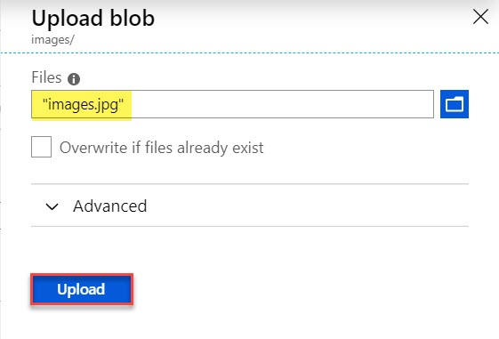

Step 18: Verify selected image successfully uploaded.
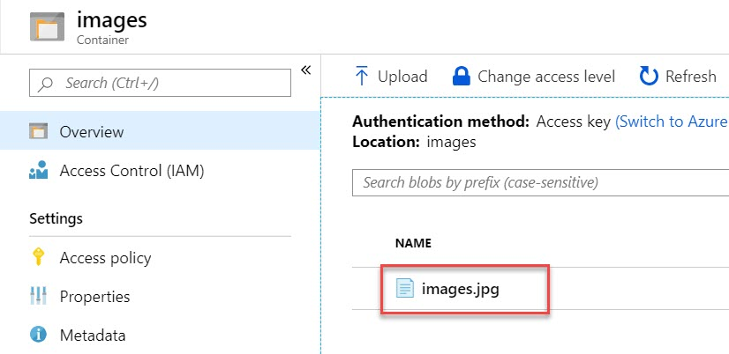

Step 19: Summary of Blob (images.jpg) will be there as below:
Click on Copy option
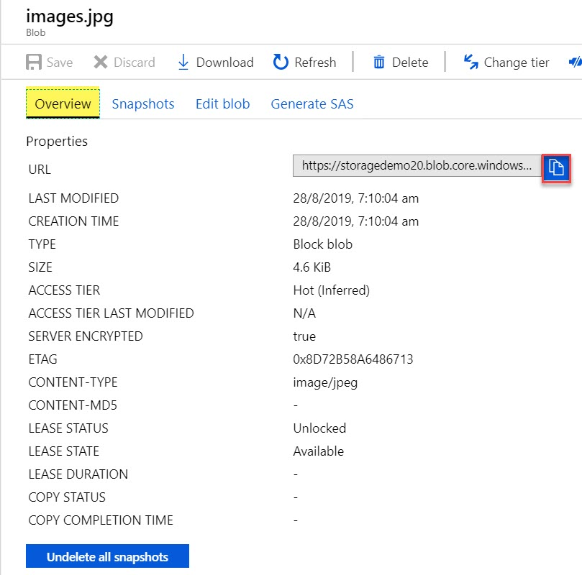

Step 20: Paste Blob URL into browser.
You will receive error because we have selected Private Container.
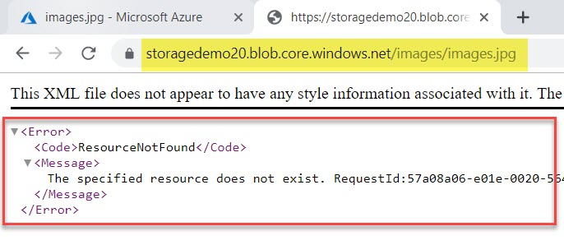

Step 21: Back to Container settings. Click on Change access level option
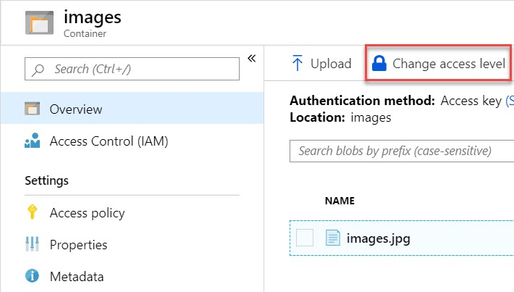

Step 22: Change Private to Container option and click on OK button.
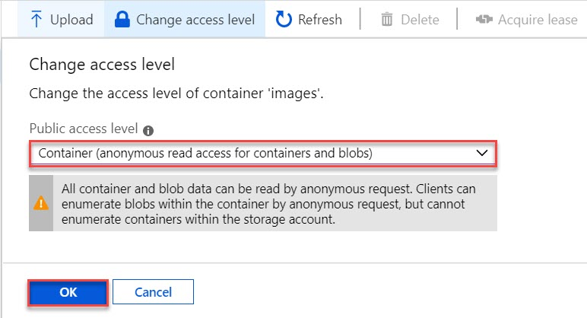

Step 23: Once again click on uploaded image file

Step 24: Refresh or paste one more time blob URL. Now you can see image is visible.
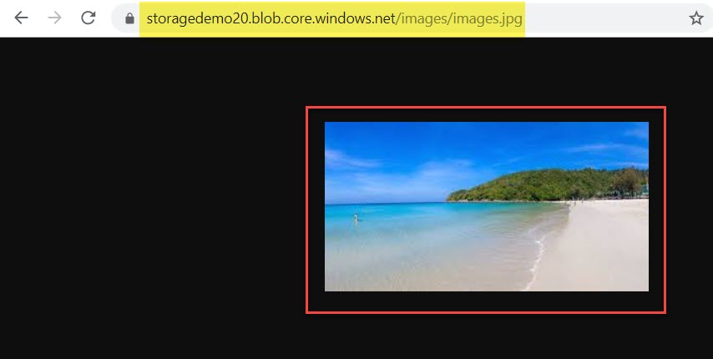

Step 25: To Download blob follow below Steps:
Click on Download option
